NAME : Mirthipati Kumar Sai
CLASS : CSE-2A
ID : S180588
SUBJECT : DATA SCIENCE WITH PYTHON
(A Real Time Data Science Project on Power Plant)

COMBINED CYCLE POWER PLANT ENERGY OUTPUT PREDICTION

Note: The dataset is downloaded from the Machine Learning UCI Repository

TABLE OF CONTENTS

Contents

Problem statement---------------------------------------------------

Importing Dataset-----------------------------------------------------

Data Cleaning-----------------------------------------------------------

Exploratory Data Analysis-------------------------------------------

Selecting the Machine Learning Model-------------------------

Model Evaluation-----------------------------------------------------

Deploy the Model Using Flask Server To Website------------

PROBLEM STATEMENT:-
The data set consists of 9568 data points collected from a Combined Cycle Power plant over 6 years (2006-2011). Here the aim of the power plant was to increase the Energy Output so the main features affecting the energy output is Temperature, Ambient Pressure, Relative humidity and Exhaust vacuum.

Importing Dataset:-

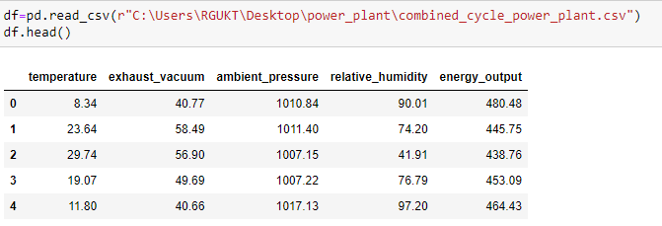

ATTRIBUTES:-
Temperature
Ambient Pressure
Relative Humidity
Exhaust vacuum
Energy output

DATASET INFORMATION:-
Number of variables | 5
Number of observations | 9568
Missing cells | 0
Missing cells (%) | 0.0%
Duplicate rows | 41

Variables

Temperature
Distinct | 2773
Minimum | 1.81
Maximum | 37.11
Mean | 19.65123119

Exhaust-vacuum
Distinct | 634
Minimum | 25.36
Maximum | 81.56
Mean | 54.30580372

Ambient-pressure
Distinct | 2517
Minimum | 992.89
Maximum | 1033.3
Mean | 1013.259078

Relative Humidity
Distinct | 4546
Minimum | 25.56
Maximum | 100.16
Mean | 73.30897784

Energy-output
Distinct | 4836
Minimum | 420.26
Maximum | 495.76
Mean | 454.3650094

Dataset Shape

Checking null –values
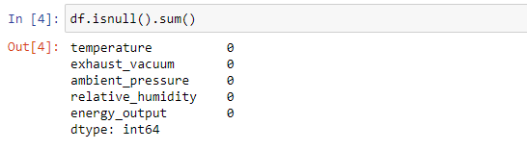
Dropping Duplicate rows
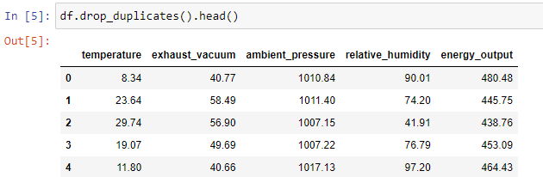

Make a list of all columns
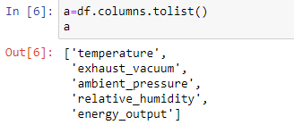

Descriptive Statistics
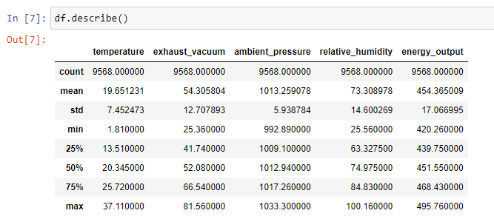
CORRELATION MAP:-
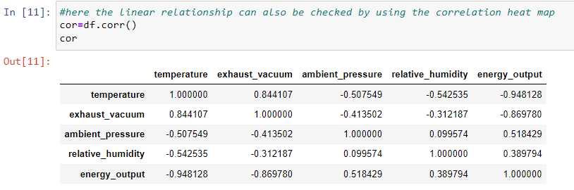



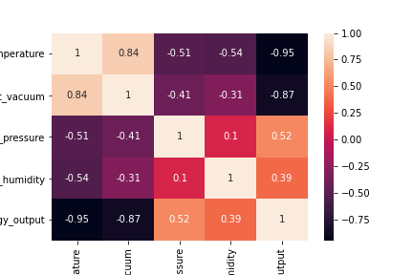

Correlations report:-
- The energy output and temperature have the high correlation (0.95). So temperature is very important feature. So there is a positive linear relationship here.
- The vacuum and energy output also have the strong negative correlation (0.87). So there is a negative linear relationship here.
- The energy output have the positive relationship with pressure and the humidity.

Exploratory Data Analysis:-

UNIVARIATE ANALYSIS



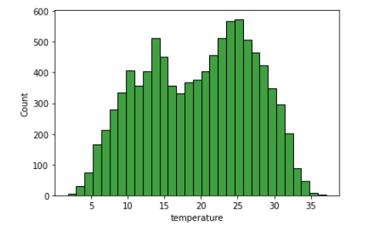

Skewness:- -0.1363930494749

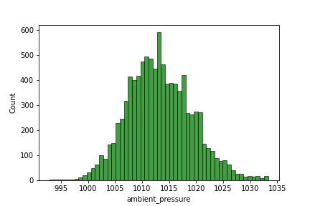227

Skewness:-0.2654446935825862

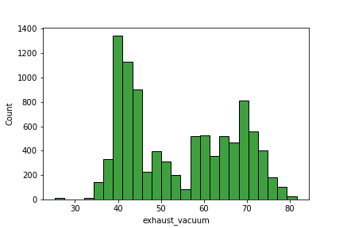
Skewness:-0.19852101136676173

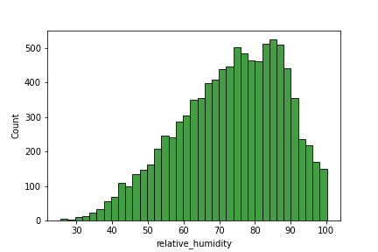
Skewness:--0.4318387491833329

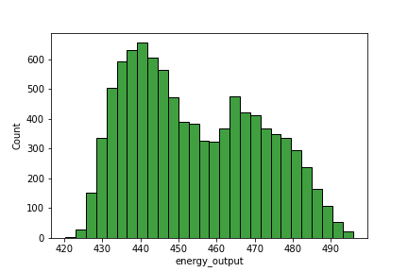

Skewness:-0.3065094354204023

BIVARIATE ANALYSIS:

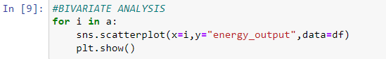

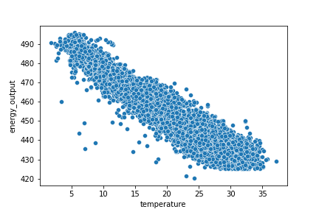
- From the scatter plot there is negative linear relationship between temperature and energy output

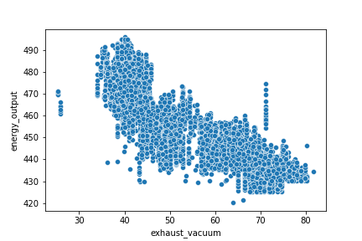
- Here also there is a somewhat linear relationship between exhaust vacuum and energy output

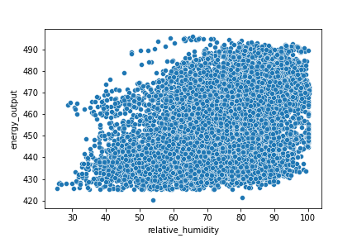

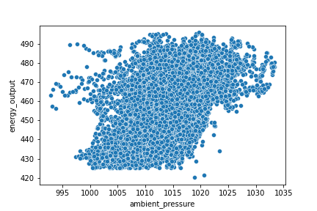
- Here there is a positive linear relationship exists between the ambient pressure and energy output

Conclusion:-

Based upon the Observations there is almost all the variables are correlated with energy output. Here in the data some variables have strong linear relationships and from the univariate analysis the data is almost normally distributed. So that’s why I choose the Multiple Linear Regression model to predict Energy Output.

Separating dependent and Independent variable

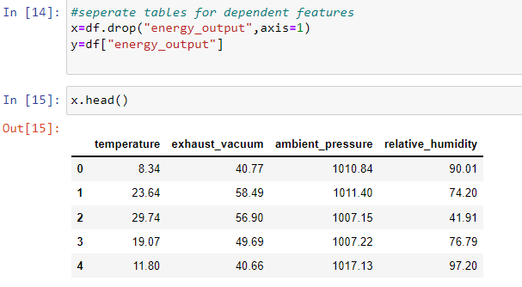

Splitting data for training and testing

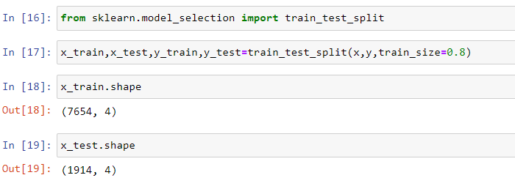

Building a Linear-Regression model

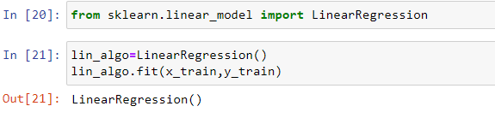

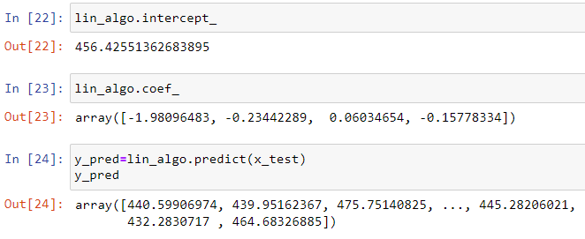

Model-Evaluation

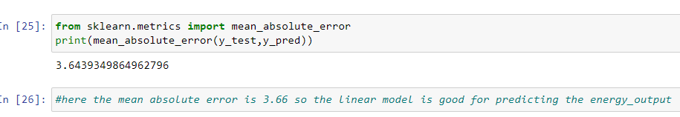

Model-Deployment using Flask Server

